

ICP Final Project Report
Project Title:

Student 1 Details
Name: Simagul Mohammadi
ID: 242296
AUW Email: auw242296@auw.edu.bd

Student 2 Details
Name: Samina Rezaei
ID: 242280
AUW Email: auw242280@auw.edu.bd

Submission Date

Project Report Guidelines
A project report documents the completed work, explaining objectives, methods, and results. It should be well-structured, concise, and supported with evidence.
General Requirements
- Length: 2–3 pages
- Include visuals (Screenshots of codes, Input, Output)
- Use clear headings
- Maintain formal writing style
- Cite sources if used (i.e. code copied from sources)

1. Abstract
Summary of the project.
The Daily Expenses Management System is a simple web-based project designed to help users record and manage their daily expenses. The project allows a user to enter expense information and display it on the webpage. HTML was used to create the structure, CSS was used for the design, and JavaScript was used to make the page interactive. The main goal of the project is to provide a simple and user-friendly way to keep track of daily spending.

2. Introduction
Background and objectives.
Managing daily expenses can be difficult when spending is recorded only in memory or on separate pieces of paper. This project was developed as a basic digital solution for recording daily expenses. The user can enter an expense and see it added to a list on the webpage. The project also helped demonstrate important web programming concepts such as HTML elements, CSS styling, JavaScript variables, functions, alerts, DOM manipulation, and event handling.

3. Methodology / Implementation
Explain how the project was done.
The project was implemented using three main technologies:
• HTML: Used to create the webpage structure, headings, input fields, buttons, and expense list.
• CSS: Used to control the layout, spacing, fonts, colors, borders, and overall appearance.
• JavaScript: Used to process user input and dynamically create and add expense items to the webpage.
In JavaScript, document.createElement("li") is used to create a new list item. appendChild() is then used to add elements such as a button to that list item. The alert() function is used to show a message to the user when required. The return statement can stop the function when the input is not valid.

4. Results / Output
Show outputs with visuals.
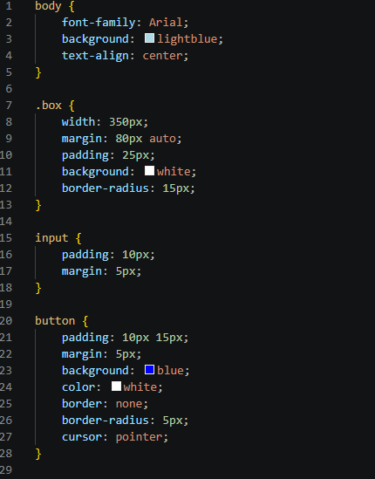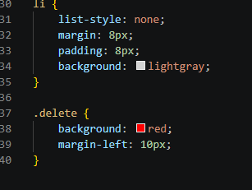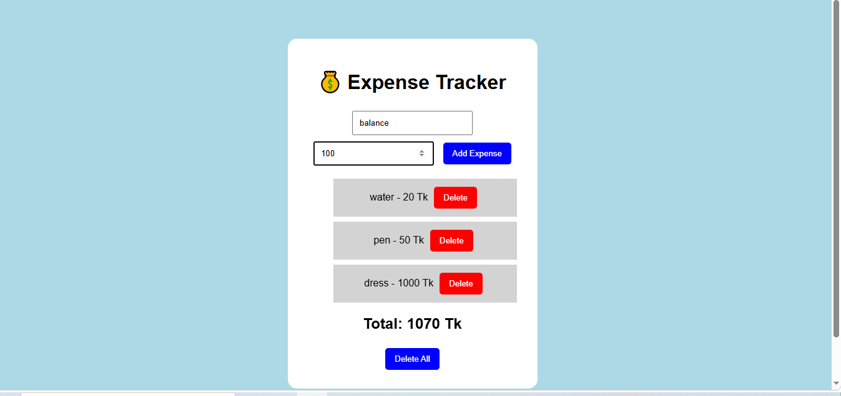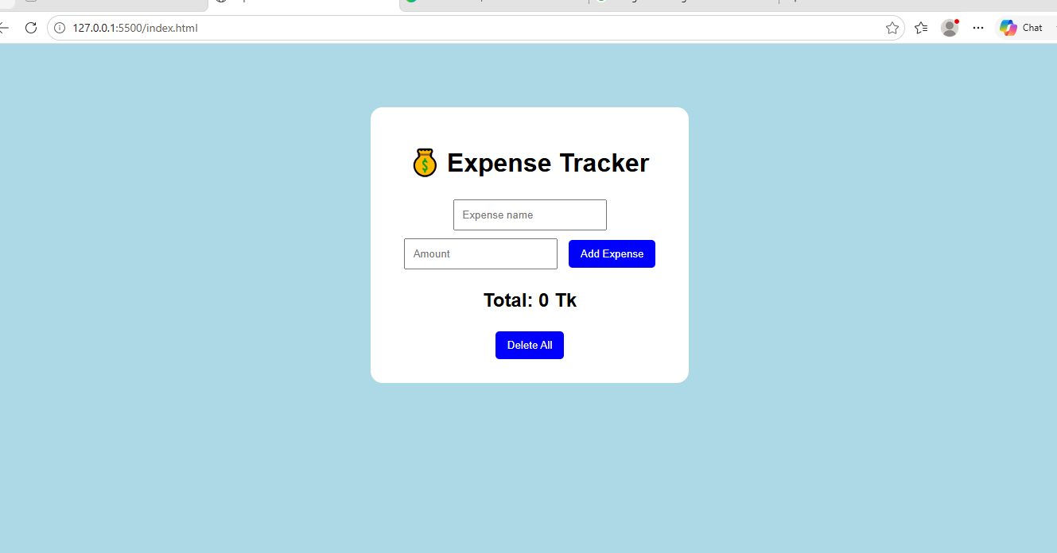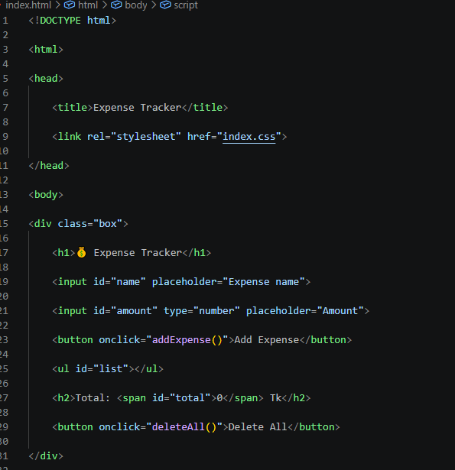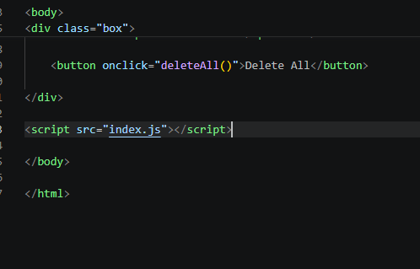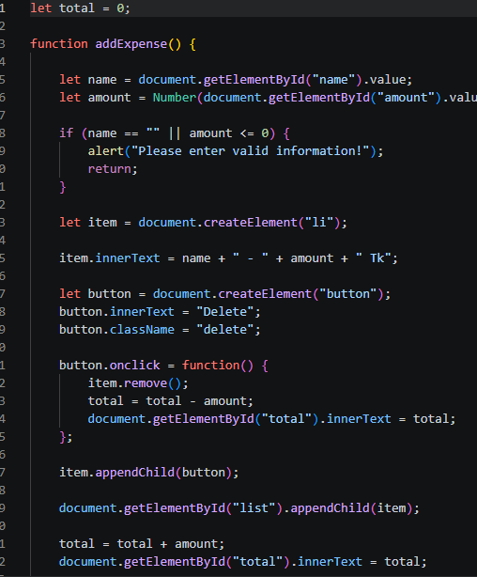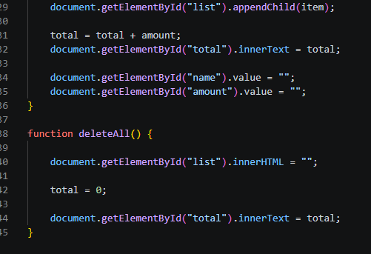

5. Challenges and Limitations
Describe issues faced.
One challenge during the development was understanding how JavaScript interacts with HTML elements. Working with document.createElement(), appendChild(), variables, and functions required practice. Another challenge was making sure that user input was handled correctly. The current project is a basic expense tracker and has some limitations: it does not yet provide advanced data storage, detailed charts, or a complete financial analysis.

6. Conclusion and Discussion
Summarize outcomes.
The Daily Expenses Management System achieved its main purpose of providing a simple interface for recording daily expenses. Through this project, I practiced HTML, CSS, and JavaScript and learned how JavaScript can create and modify HTML elements dynamically. The project also improved my understanding of user input, functions, alerts, and DOM manipulation.

7. Future Work
Suggest improvements or mention incomplete parts.
In the future, the project can be improved by adding more features. These may include calculating the total amount spent, adding expense categories, saving data in local storage, editing and deleting expenses, and displaying expenses using charts. A responsive mobile-friendly design could also be added.

8. References
List sources.
Chat GPT

9. Individual Contributions
Describe each member’s contribution in details
I contributed to the development of the Daily Expenses Management System by working on the webpage structure, styling, and JavaScript functionality. I worked with HTML elements, CSS design, JavaScript functions, user input, alerts, and DOM methods such as createElement() and appendChild(). I also tested the project and checked the final output.

